

DEPARTMENT OF AI AND DS

**FAVOURITE CITY INFORMATION**

**A Front-End UI UX Project**

**By**

CLASS: 3BTCS AIML A

Aliviya Joby-2462029

Femi K E-2462069

Devananda Vaniyan Surendran-2462063

**Instructor** : Dhiraj Alate

**Date**: 26th September 2025

# ABSTRACT

This project presents a responsive Beijing city guide website using HTML, CSS, Bootstrap, and JavaScript. It highlights key attractions, restaurants, events, and activities while offering an interactive user experience through multimedia and maps. Designed with a dark theme, the site demonstrates modern web design practices and usability principles effectively.

# OBJECTIVES

• To design a simple and responsive travel guide website for Beijing.

• To demonstrate the use of Bootstrap components for layout and styling.

• To integrate multimedia elements like images and maps for engagement.

• To ensure smooth navigation across multiple sections of the site.

# SCOPE

**Inclusions**

* Introduction, attractions, restaurants, activities, and local events.
* Contact information with a call-to-action button for tours.
* Dark theme UI for readability and aesthetics.
* Google Maps integration for geographical context.

**Exclusions**

* Backend booking functionality (only frontend demo).
* Real-time event updates or dynamic content.
* Payment gateway and advanced user accounts.
* Multilingual support (English only).

# TOOLS AND TECHNOLOGY

• **HTML5** – Structure and semantic content.

• **CSS3** – Styling and layout customization.

• **Bootstrap 5.3** – Responsive design and prebuilt components.

• **JavaScript & jQuery** – Interactivity and dynamic behavior.

• **External APIs** – Google Maps embedded.

# HTML STRUCTURE OVERVIEW

• <nav> – Navigation bar with links to sections.

• <header> – Hero section with welcome message and CTA button.

• <main> – Contains multiple <section> blocks (intro, attractions, food, things to do, events, contact).

• <footer> – Credits and closing notes.

• Semantic tags used for better readability and structure.

# CSS STYLING STRATEGY

• Bootstrap classes for layout and responsiveness.

• Dark theme applied via bg-dark and text-light.

• Cards, borders, and shadows to highlight content sections.

• Responsive images and embedded maps using ratio.

• Minimal custom CSS for overriding Bootstrap defaults.

# KEY FEATURES

| **Feature** | **Description** |
| --- | --- |
| Responsive Navbar | Mobile-friendly with collapsible toggler. |
| Hero Section | Welcoming intro with CTA for exploring attractions. |
| Attractions Grid | Cards layout with images and descriptions. |
| Google Maps Integration | Interactive map showing Beijing location. |
| Dark Theme Aesthetic | Consistent styling for modern UI. |

# 

# CHALLENGES FACED AND SOLUTIONS

• **Image loading issues** → Corrected invalid src attributes.

• **Maintaining readability in dark mode** → Used border-secondary and text-light for balance.

• **Responsiveness on small screens** → Bootstrap grid system handled alignment and stacking.

# OUTCOME

* Successfully built a functional, aesthetic, and informative Beijing city guide.
* Demonstrated responsive design principles with Bootstrap.
* Achieved smooth navigation and visual appeal through multimedia integration.
* Provided a strong foundation for extending into a real-world travel platform.

.

# FUTURE ENHANCEMENTS

• Add multilingual support (Chinese, English, others).

• Implement real-time event updates via APIs.

• Add user login, booking system, and reviews.

• Enhance accessibility features for inclusive design.

• Integrate animations for interactive user engagement.

# SAMPLE CODE

2 PAGES OF HTML CODE(SAMPLE)

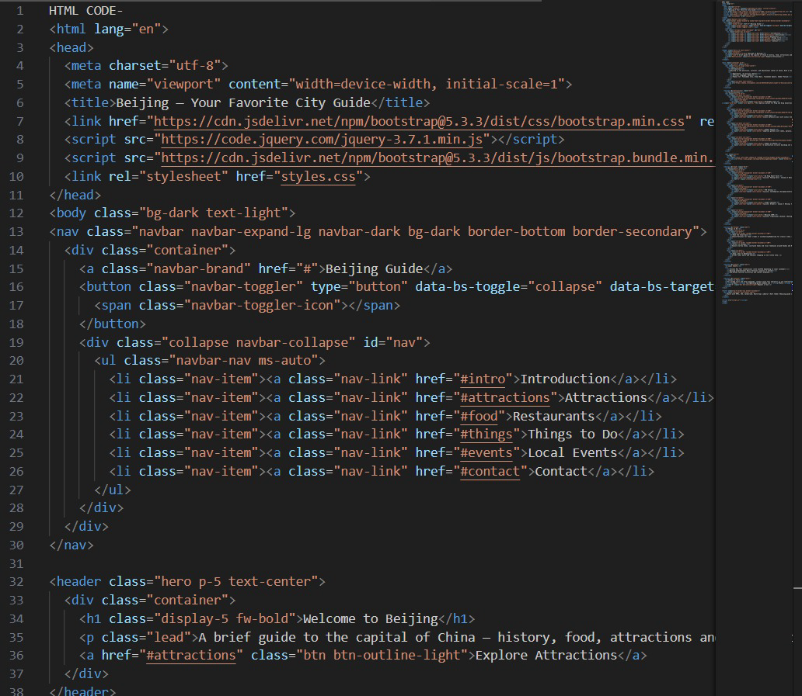

# 

2 PAGES OF CSS CODE(SAMPLE)

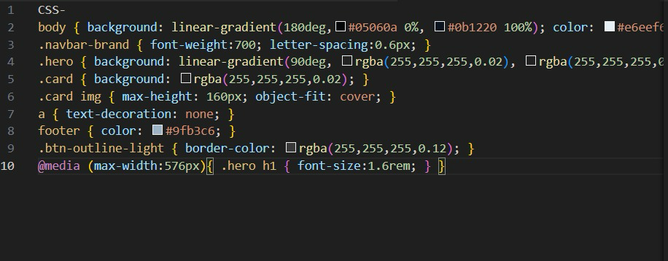

# OUTPUT

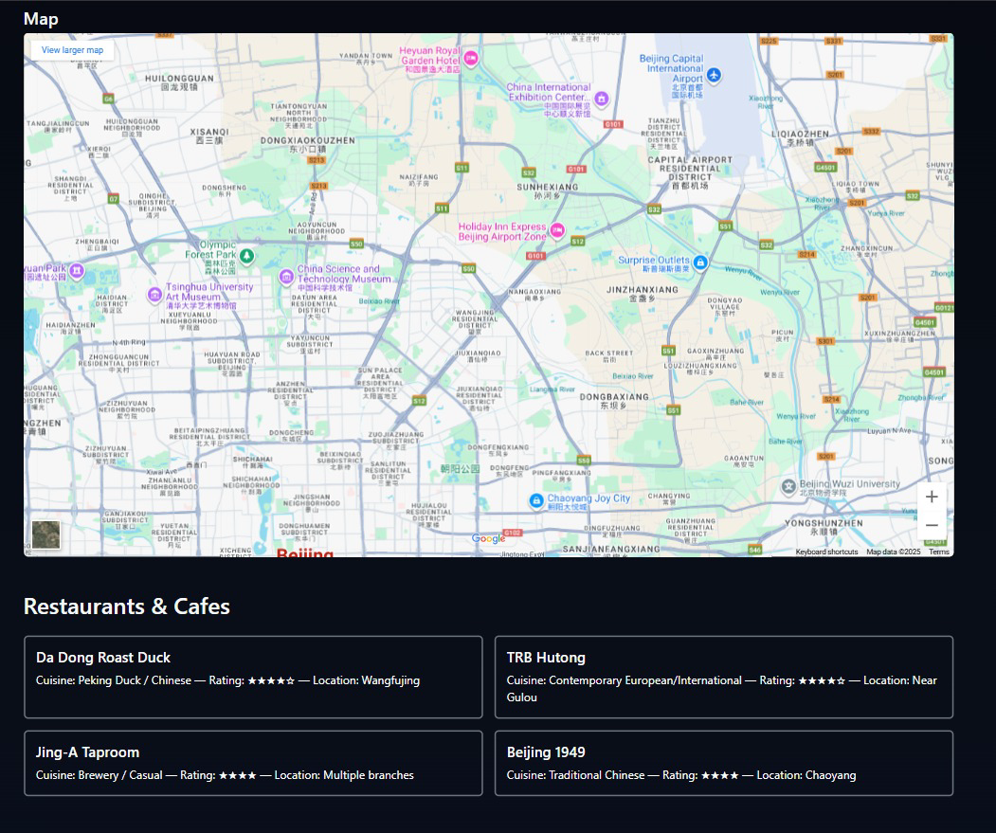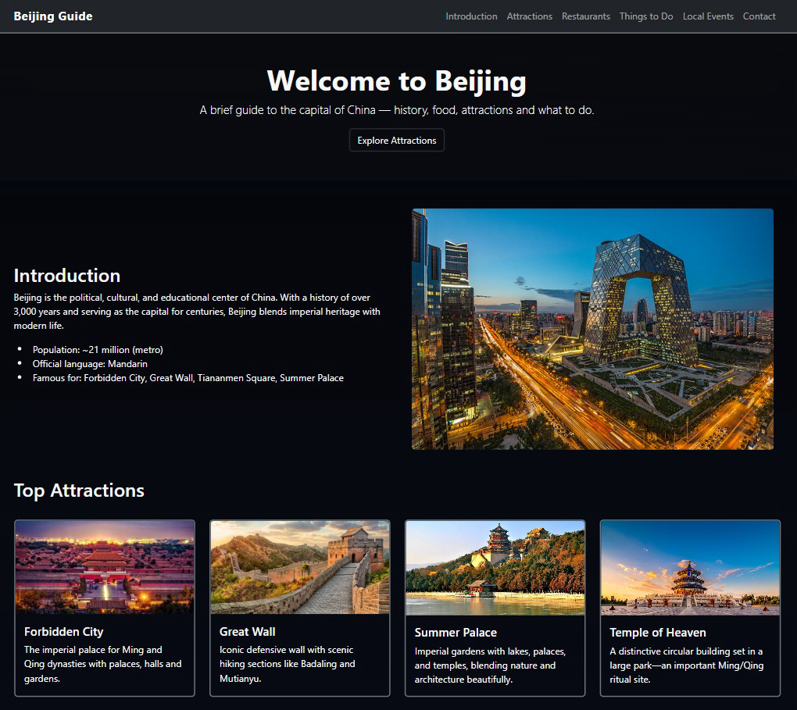

# CONCLUSION

The Beijing city guide project successfully showcases how front-end technologies can create an engaging, informative, and user-friendly travel webpage. By integrating Bootstrap for responsiveness and Google Maps for interactivity, it achieves both aesthetics and functionality. The outcome serves as a strong base for future expansion into a real travel platform.

# REFERENCES

* MDN Web Docs: https://developer.mozilla.org/
* W3C Accessibility Guidelines:<https://www.w3.org/WAI/>
* L&T LMS:<https://learn.lntedutech.com/Landing/MyCourse>